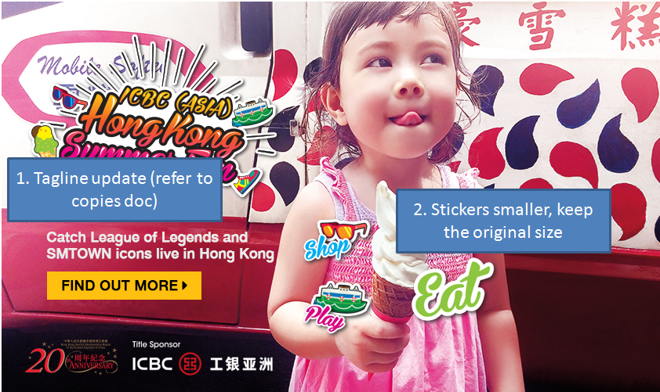

XXXXX

**ICBC (Asia) e-Sports and Music Festival Hong Kong**

XXXXX

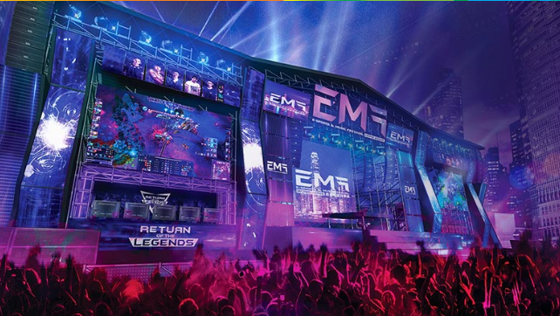

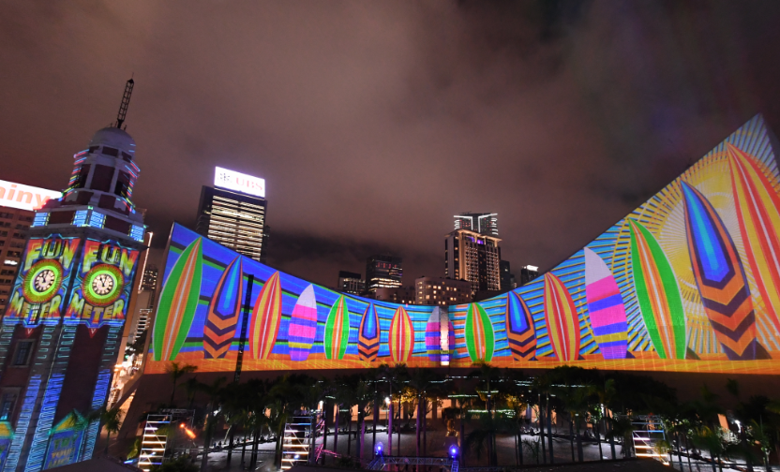

**Hong Kong Pulse Light Show**

XXXX

**Pic TBC**

**Other Exciting Happenings**

XXXX

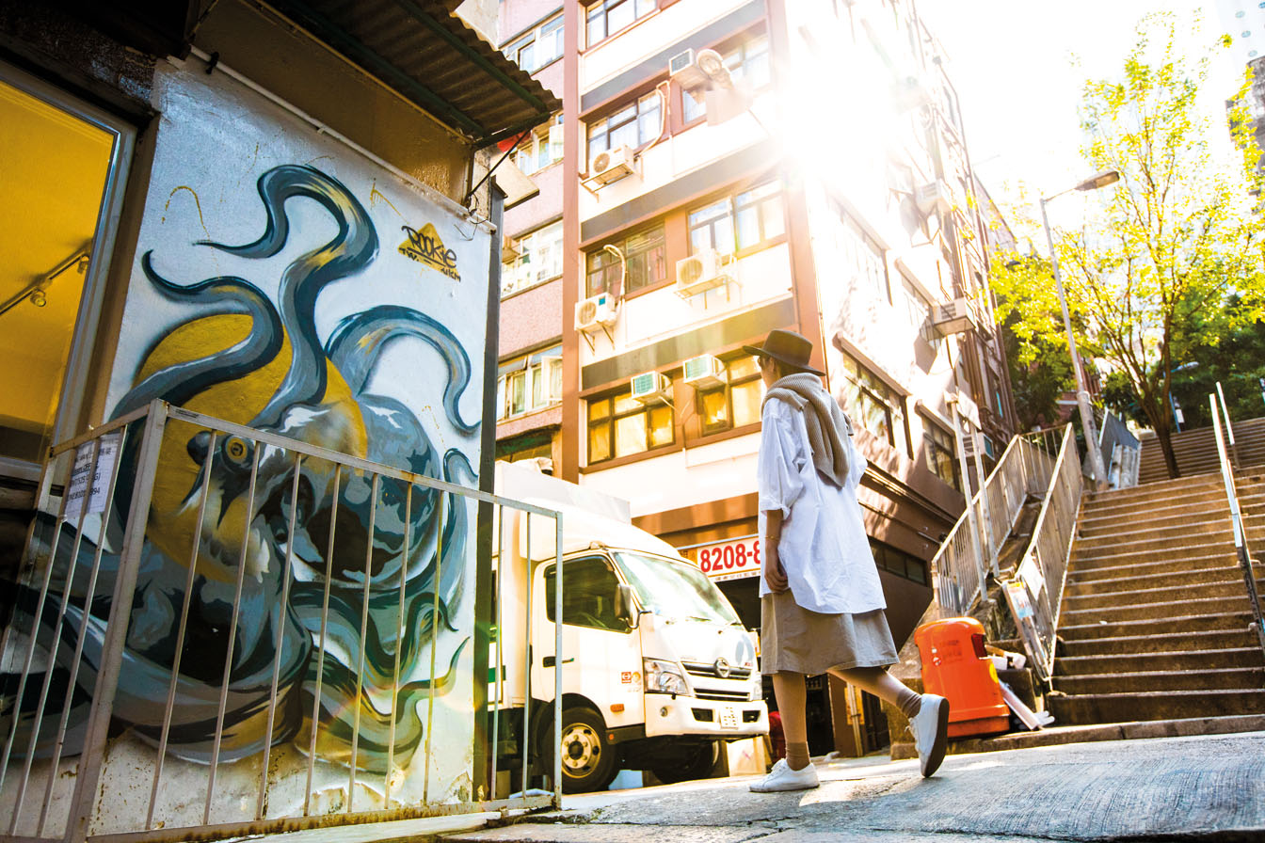

**Cool Neighborhoods**

XXXXX

**EN**

**Intro Landing:**

<http://www.discoverhongkong.com/eng/summerfun/?WT.mc_id=117284&utm_source=eNews&utm_medium=eNews&utm_content=intro-en&utm_campaign=summerfun>

**EMF**

<http://www.discoverhongkong.com/eng/summerfun/festival.html?WT.mc_id=117287&utm_source=eNews&utm_medium=eNews&utm_content=emf-en&utm_campaign=summerfun>

**Hong Kong Pulse Light Show**

<http://www.discoverhongkong.com/eng/see-do/highlight-attractions/harbour-view/hk-pulse.jsp?WT.mc_id=117290&utm_source=eNews&utm_medium=eNews&utm_content=pulse-en&utm_campaign=summerfun>

**Cool Neighborhoods**

<http://discoverhongkong.com/eng/summerfun/eat.html?WT.mc_id=117293&utm_source=eNews&utm_medium=eNews&utm_content=cool-en&utm_campaign=summerfun#section-district>

**Other Exciting Happenings**

<http://www.discoverhongkong.com/eng/summerfun/events.html?WT.mc_id=117296&utm_source=eNews&utm_medium=eNews&utm_content=events-en&utm_campaign=summerfun>

**TC**

**KV image same as eng, use TC lock up and tagline, remove 20A logo**

**Intro Landing:**

<http://www.discoverhongkong.com/tc/summerfun/?WT.mc_id=117285&utm_source=eNews&utm_medium=eNews&utm_content=intro-tc&utm_campaign=summerfun>

**EMF**

<http://www.discoverhongkong.com/tc/summerfun/festival.html?WT.mc_id=117288&utm_source=eNews&utm_medium=eNews&utm_content=emf-tc&utm_campaign=summerfun>

**Hong Kong Pulse Light Show**

<http://www.discoverhongkong.com/tc/see-do/highlight-attractions/harbour-view/hk-pulse.jsp?WT.mc_id=117291&utm_source=eNews&utm_medium=eNews&utm_content=pulse-tc&utm_campaign=summerfun>

**Cool Neighborhoods**

<http://discoverhongkong.com/tc/summerfun/eat.html?WT.mc_id=117294&utm_source=eNews&utm_medium=eNews&utm_content=cool-tc&utm_campaign=summerfun#section-district>

**Other Exciting Happenings**

<http://www.discoverhongkong.com/tc/summerfun/events.html?WT.mc_id=117297&utm_source=eNews&utm_medium=eNews&utm_content=events-tc&utm_campaign=summerfun>

**SC**

**KV image same as eng, use SC lock up and tagline**

**Intro Landing:**

<http://www.discoverhongkong.com/china/summerfun/?WT.mc_id=117286&utm_source=eNews&utm_medium=eNews&utm_content=intro-sc&utm_campaign=summerfun>

**EMF**

<http://www.discoverhongkong.com/china/summerfun/festival.html?WT.mc_id=117289&utm_source=eNews&utm_medium=eNews&utm_content=emf-sc&utm_campaign=summerfun>

**Hong Kong Pulse Light Show**

<http://www.discoverhongkong.com/china/see-do/highlight-attractions/harbour-view/hk-pulse.jsp?WT.mc_id=117292&utm_source=eNews&utm_medium=eNews&utm_content=pulse-sc&utm_campaign=summerfun>

**Cool Neighborhoods**

<http://discoverhongkong.com/china/summerfun/eat.html?WT.mc_id=117295&utm_source=eNews&utm_medium=eNews&utm_content=cool-sc&utm_campaign=summerfun#section-district>

**Other Exciting Happenings**

<http://www.discoverhongkong.com/china/summerfun/events.html?WT.mc_id=117298&utm_source=eNews&utm_medium=eNews&utm_content=events-sc&utm_campaign=summerfun>